**Reference No:** C15…..

**Damage Report Date:** .14/08/13...

**Incidents must be reported immediately.**

Damage found in Container must not to be touched until pictures have been taken to effectively demonstrate to stake holders how damage could have occurred?

In Container Container No. DRYU9466414

In Warehouse How was it damaged?

Product

RXV375B S/N = 21T080633TV

*Insert* Picture:

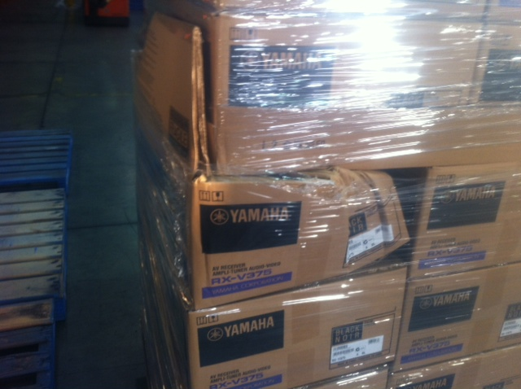

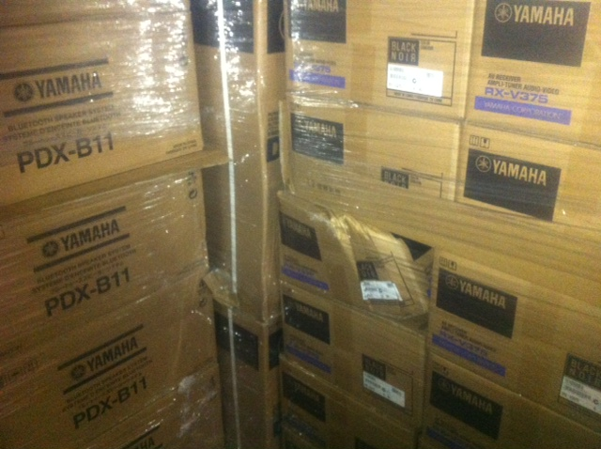

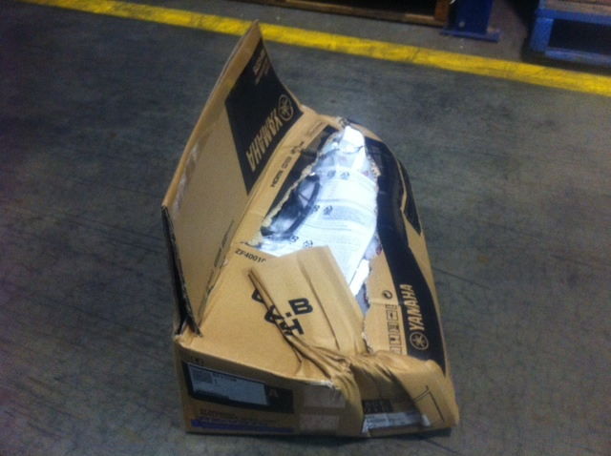

Reported by…… Frank Vastag ……………………………………….